NEET Preparation in a different way ……………Dr. OP Singh

**NEET CHAPTER ANATOMY OF FLOWERING PLANTS**

**LEARNING THROUGH DIAGRAM & COMPARASION COLUMN**

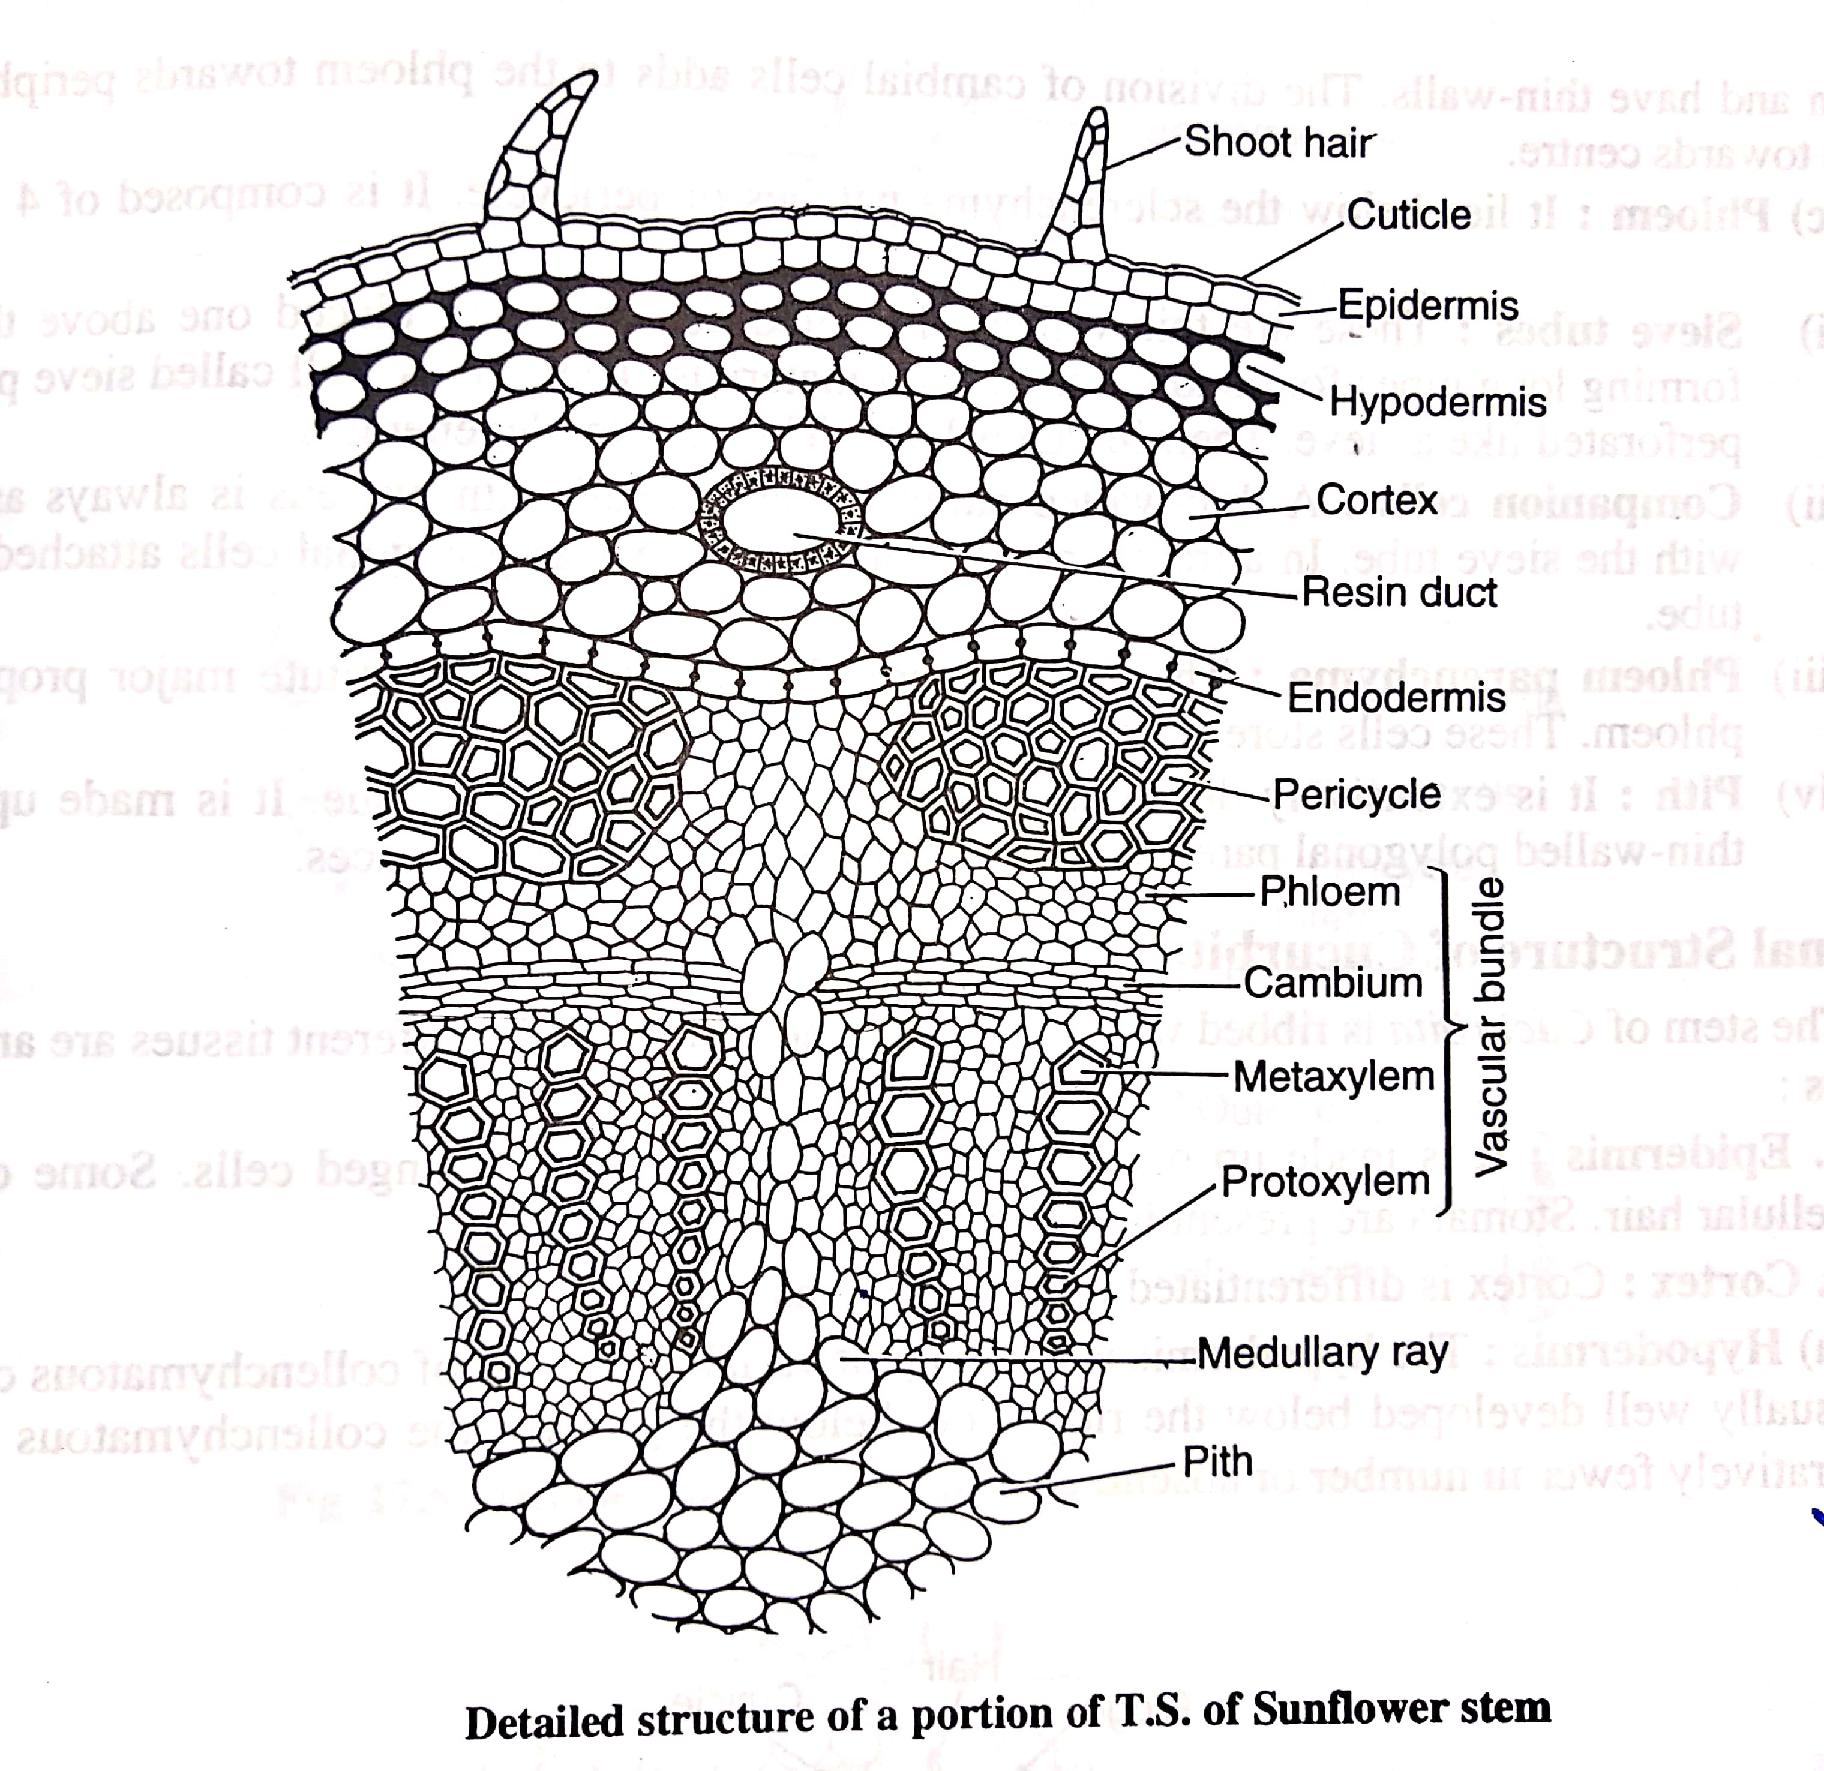

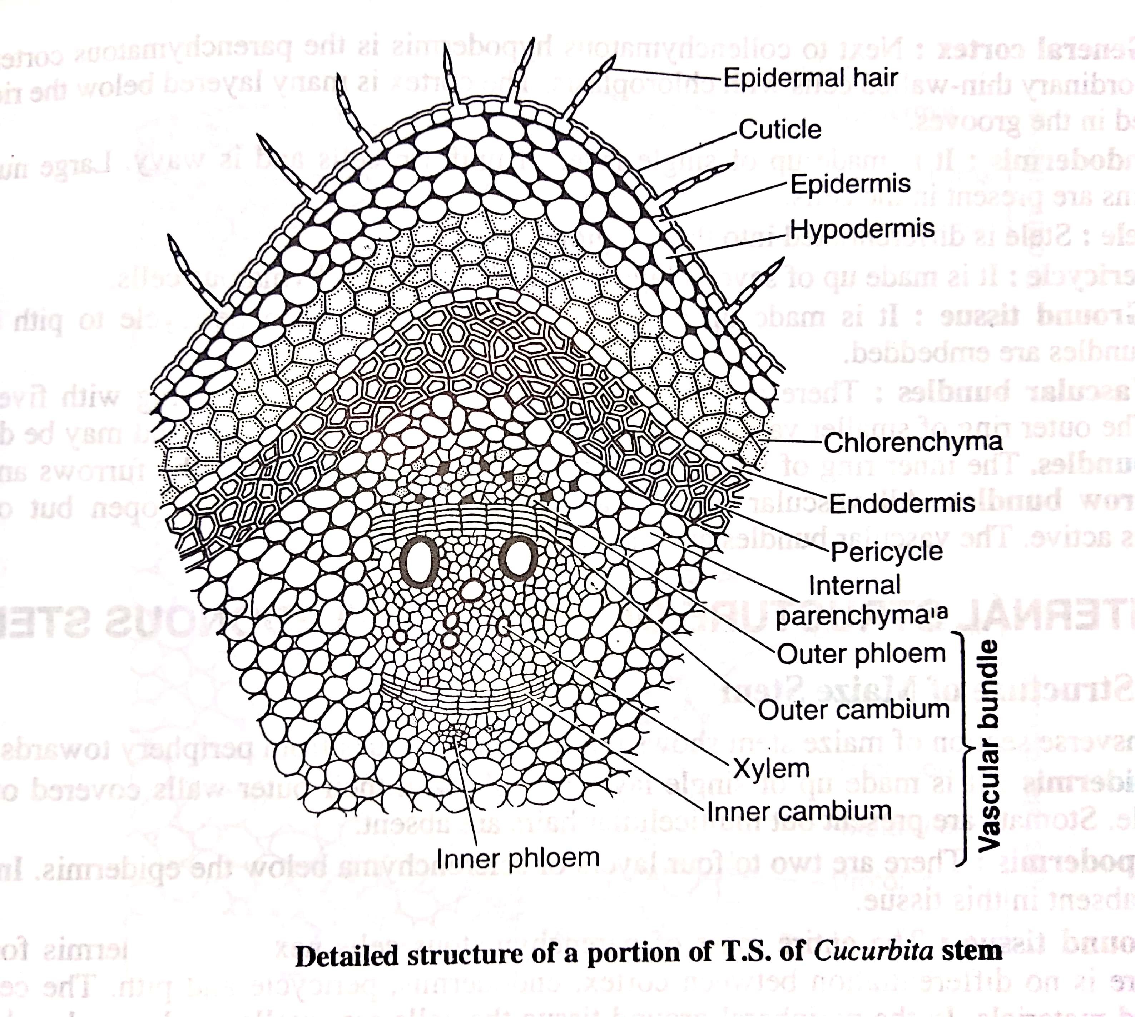

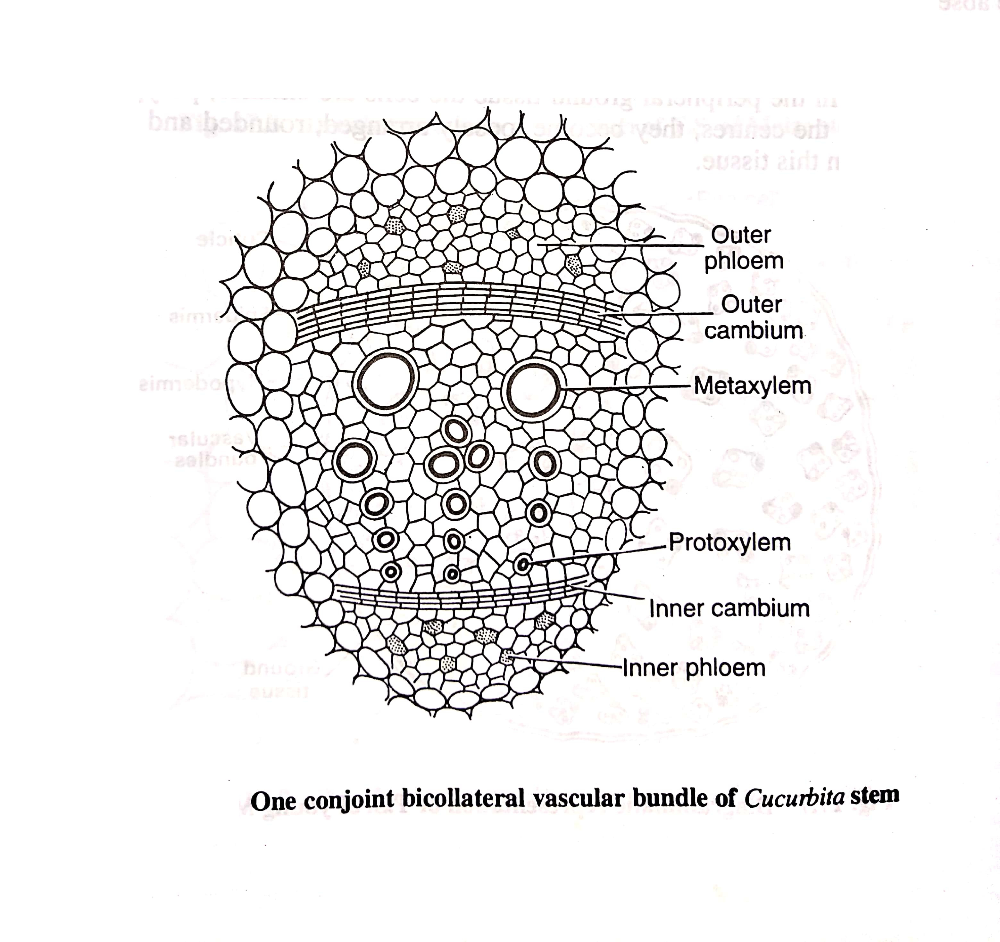

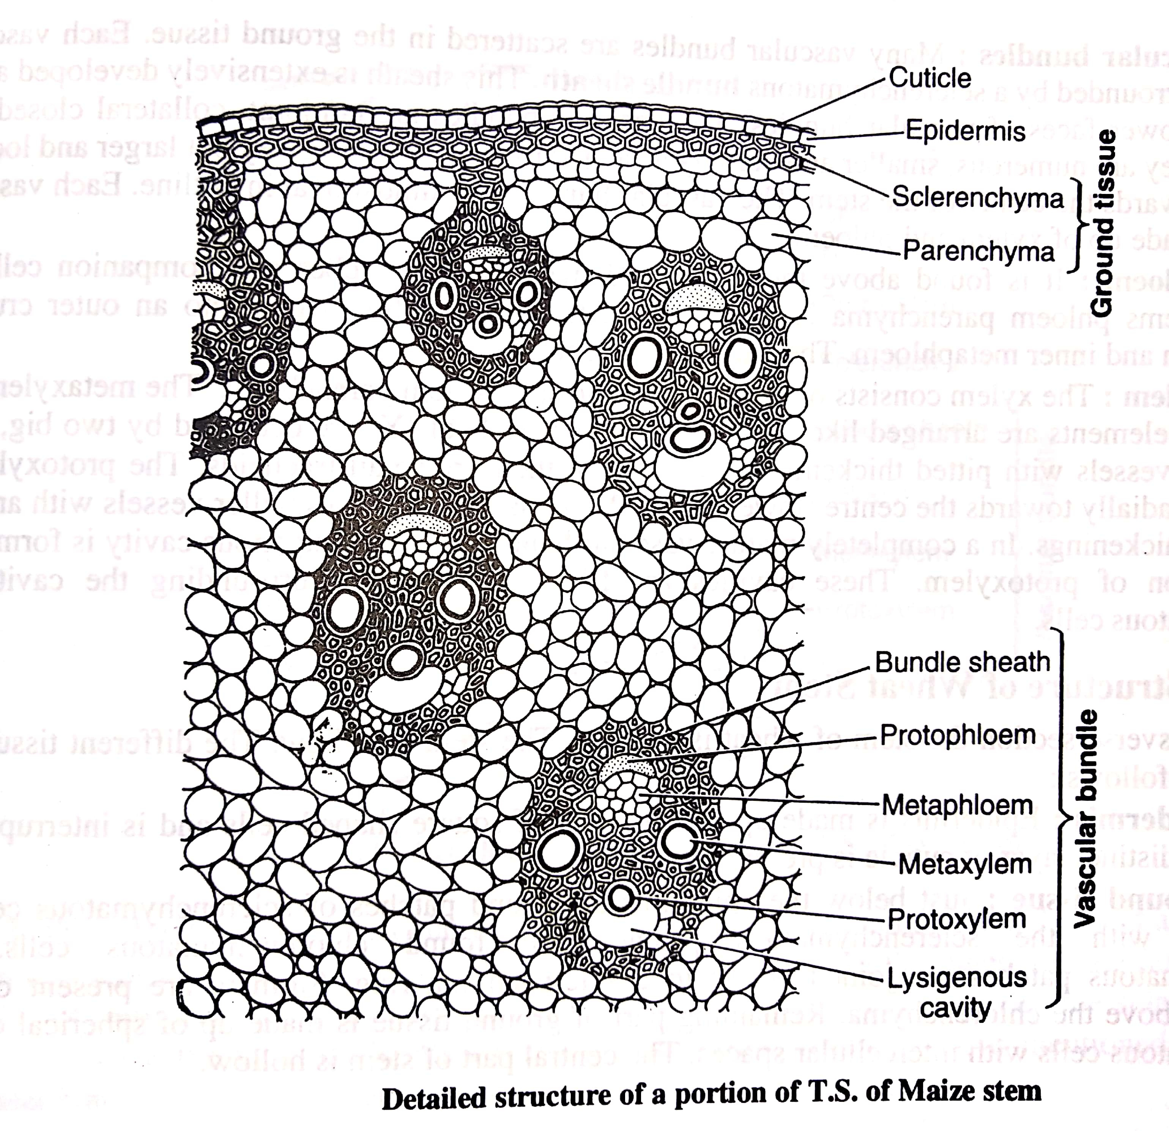

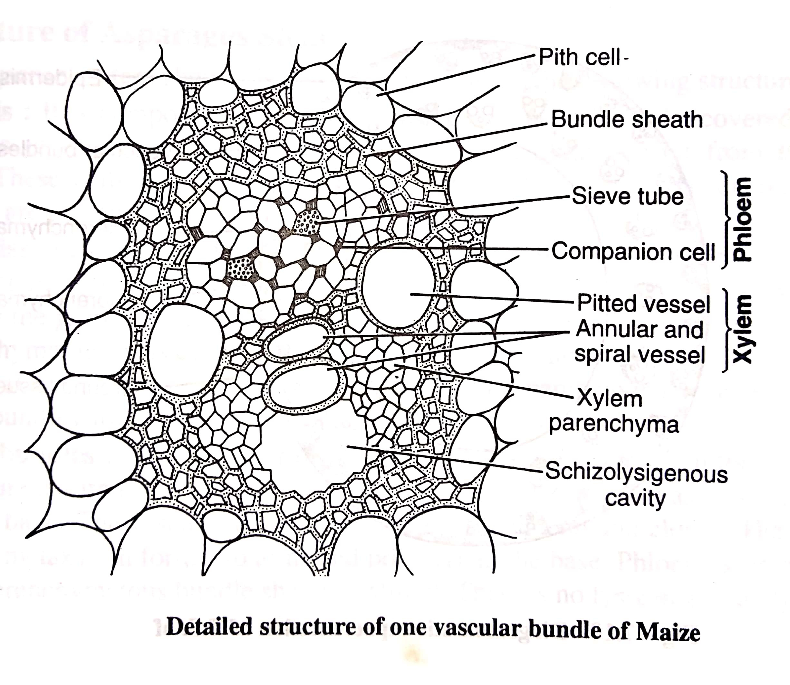

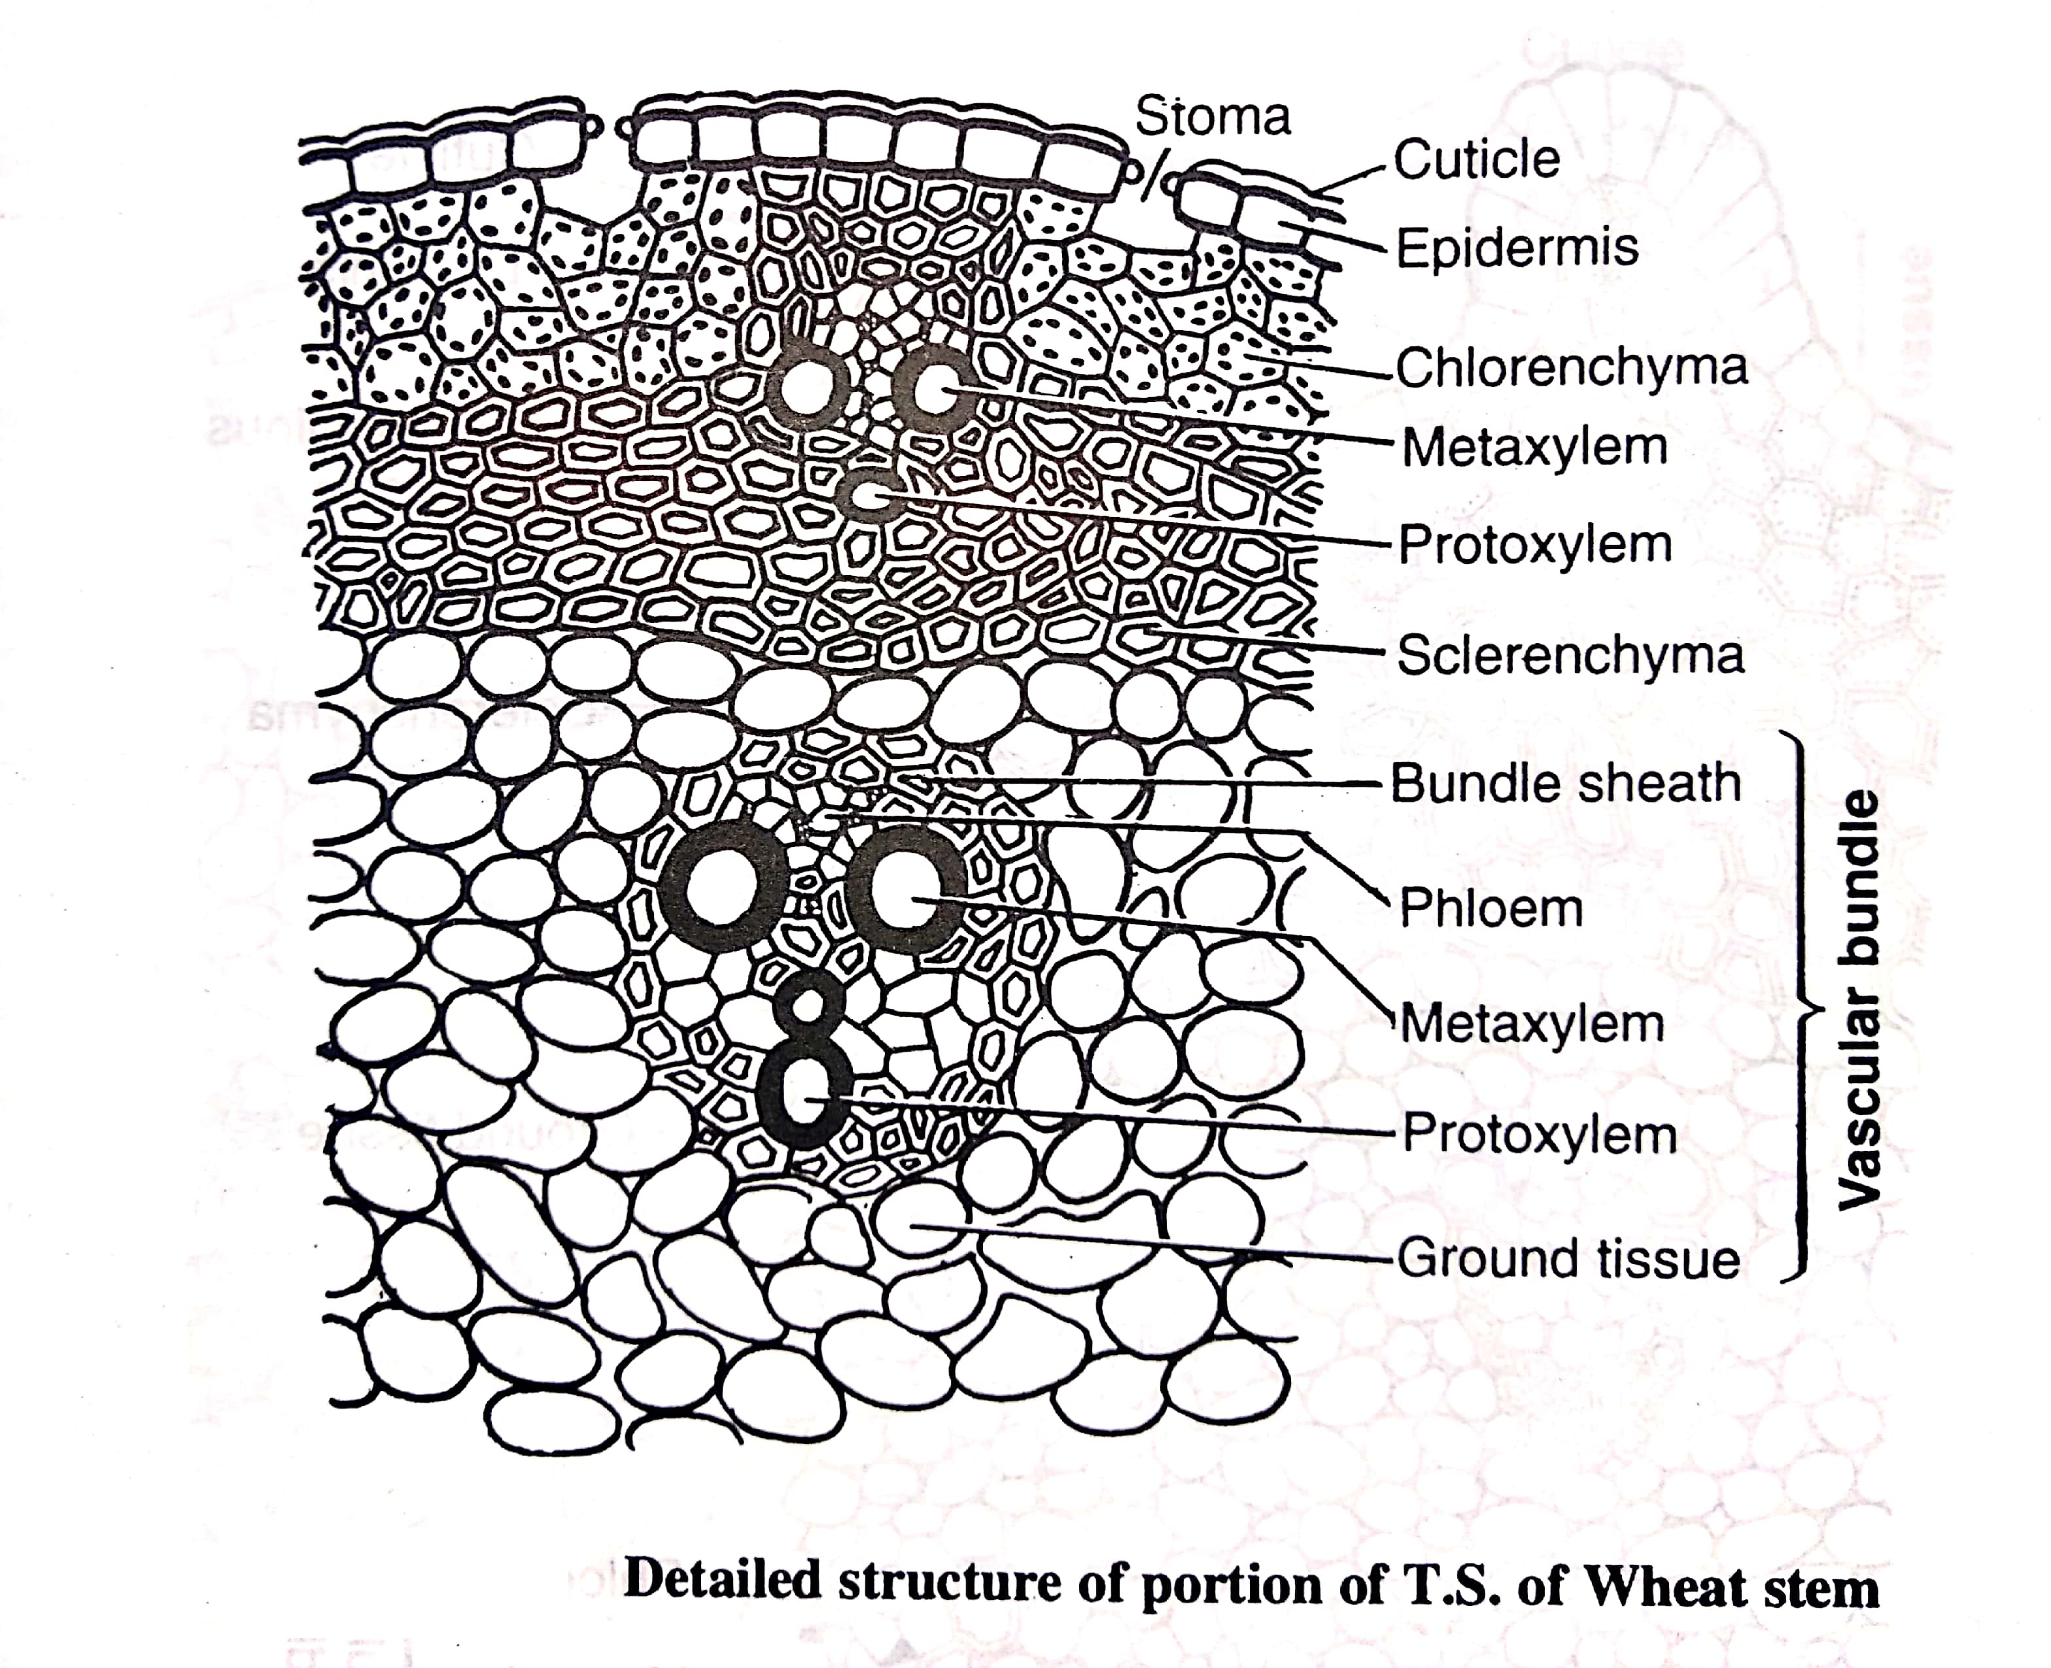

**DIFFERENCE IN THE ANATOMY OF DICOT AND MONOCOT LEAVES**

|  |  |  |
| --- | --- | --- |
| **Character** | **Monocotyledonous stem** | **Dicotyledonous stem** |
| 1. Vascular bundles | 1. Scattered 2. Conjoint, collateral, closed 3. Bundle sheath usually present 4. Phloem parenchyma absent 5. Xylem vessels arranged either in Y or V shaped manner | 1. Vascular bundles in a ring. 2. Conjoint, collateral or   bicollateral and open.   1. Bundle sheath absent. 2. Phloem parenchyma   present.  (e) Not so. |
| 1. Pith (Medulla) | Absent | Made up of parenchymatous cells situated in the centre of stem. |
| 1. Ground tissue | Ground tissue is not differentiated into the cortex and pith | Differentiated into the cortex and pith. |
| 1. Hypodermis | Usually sclerenchymatous | Collenchymatous. |
| 1. Endodermis | Absent | One layered, starchy sheath which is usually not well differentiated |
| 1. Pericycle | Absent | Made up of one or more layers of parenchymatous and/or sclerenchymatous cells. |
| 1. Medullary rays | Absent | Found in between vascular bundles. |

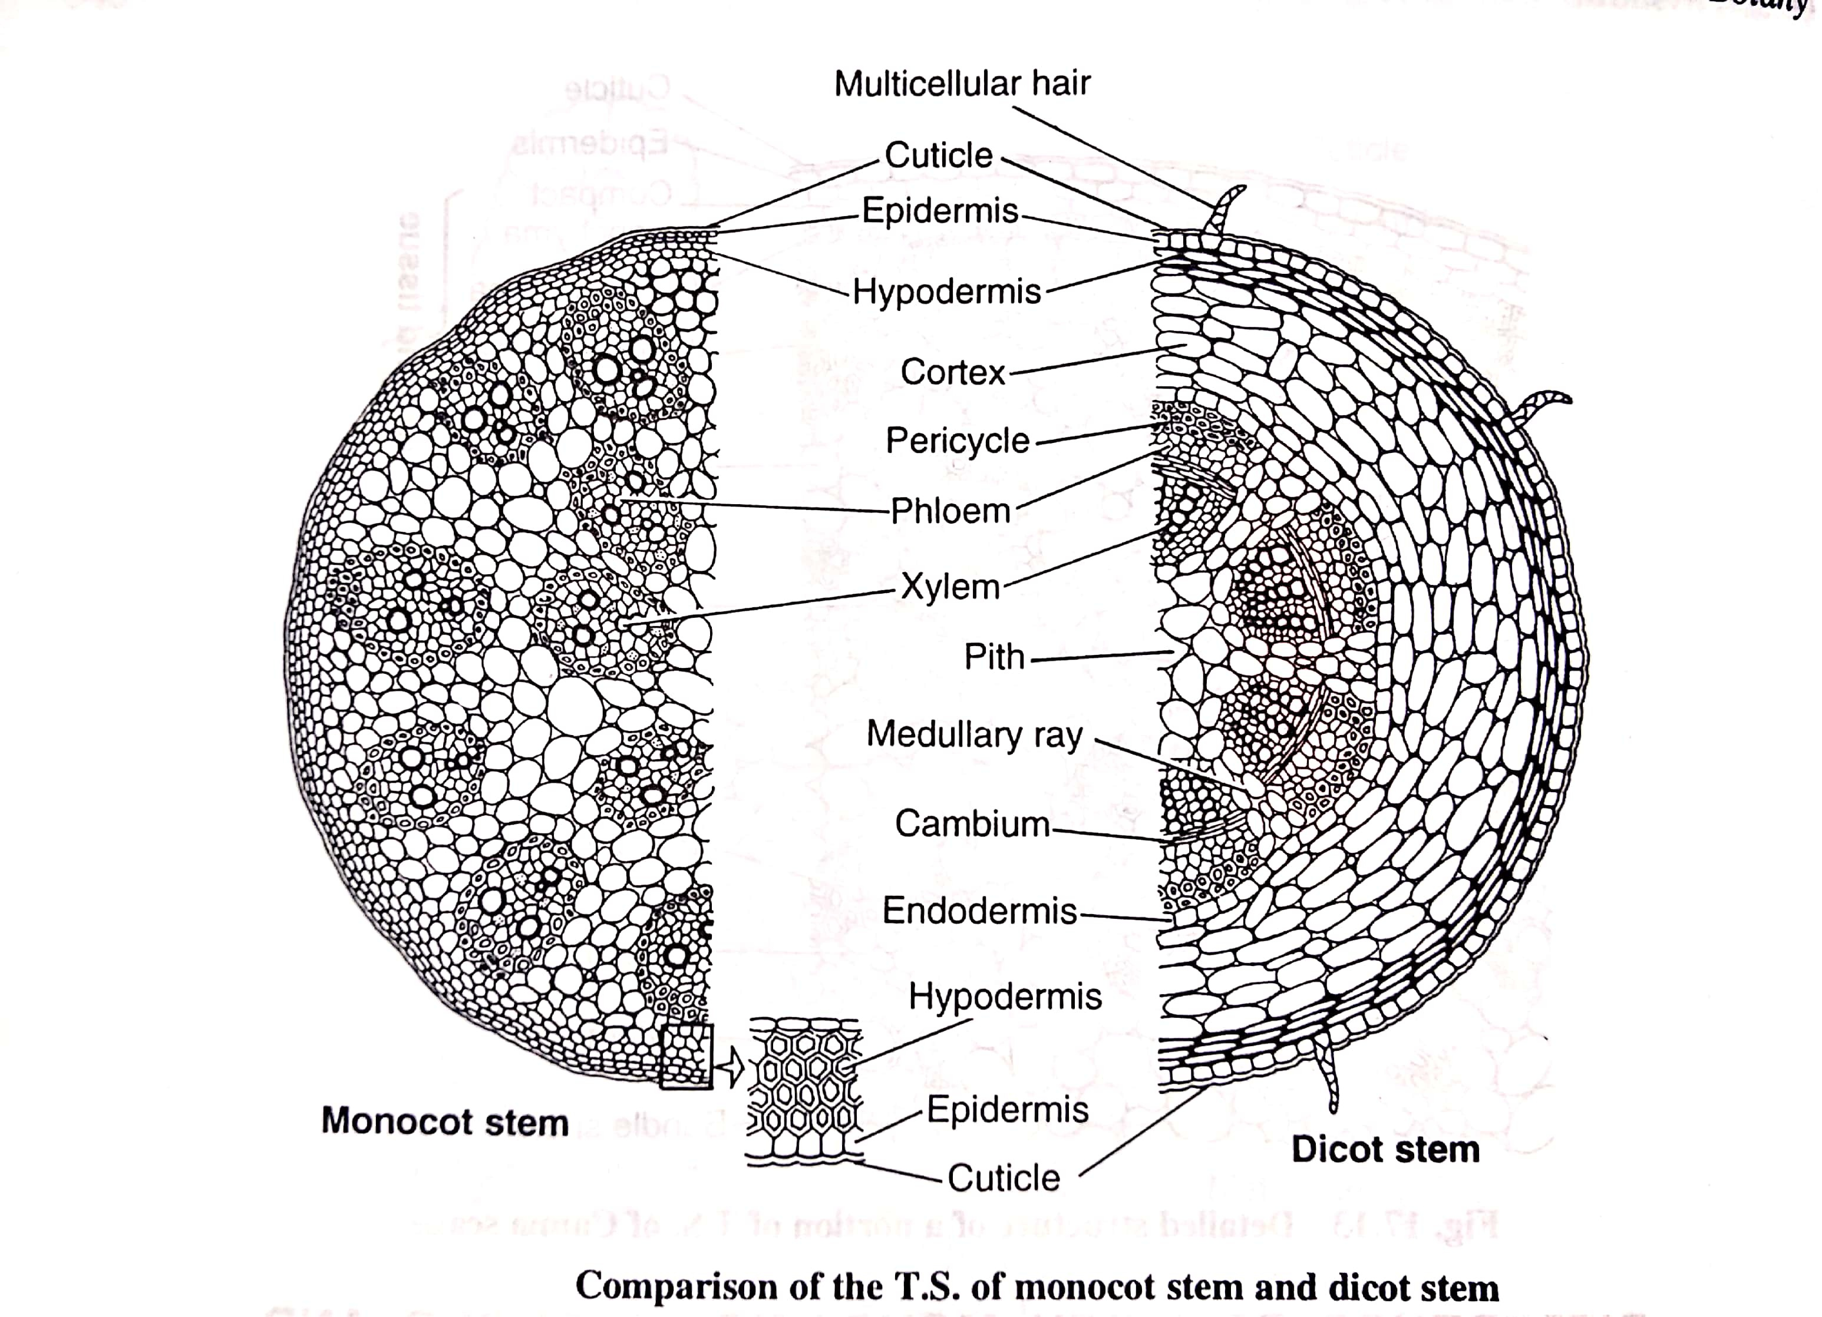

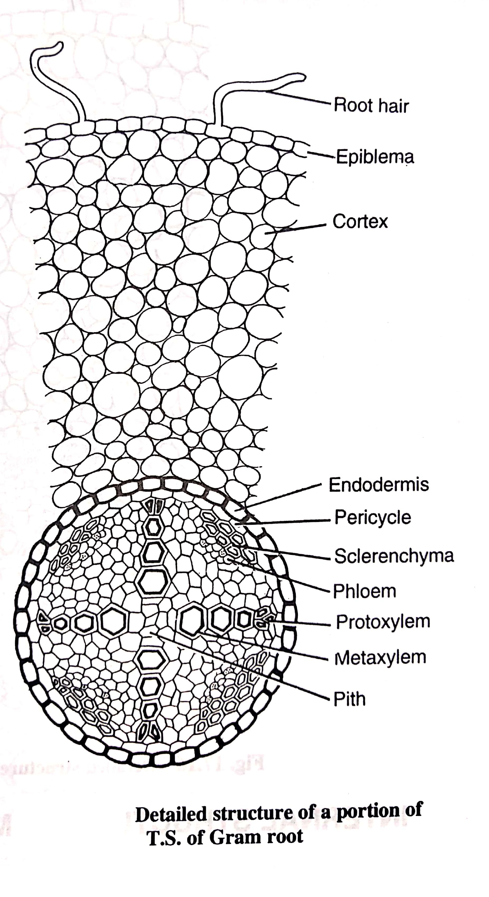

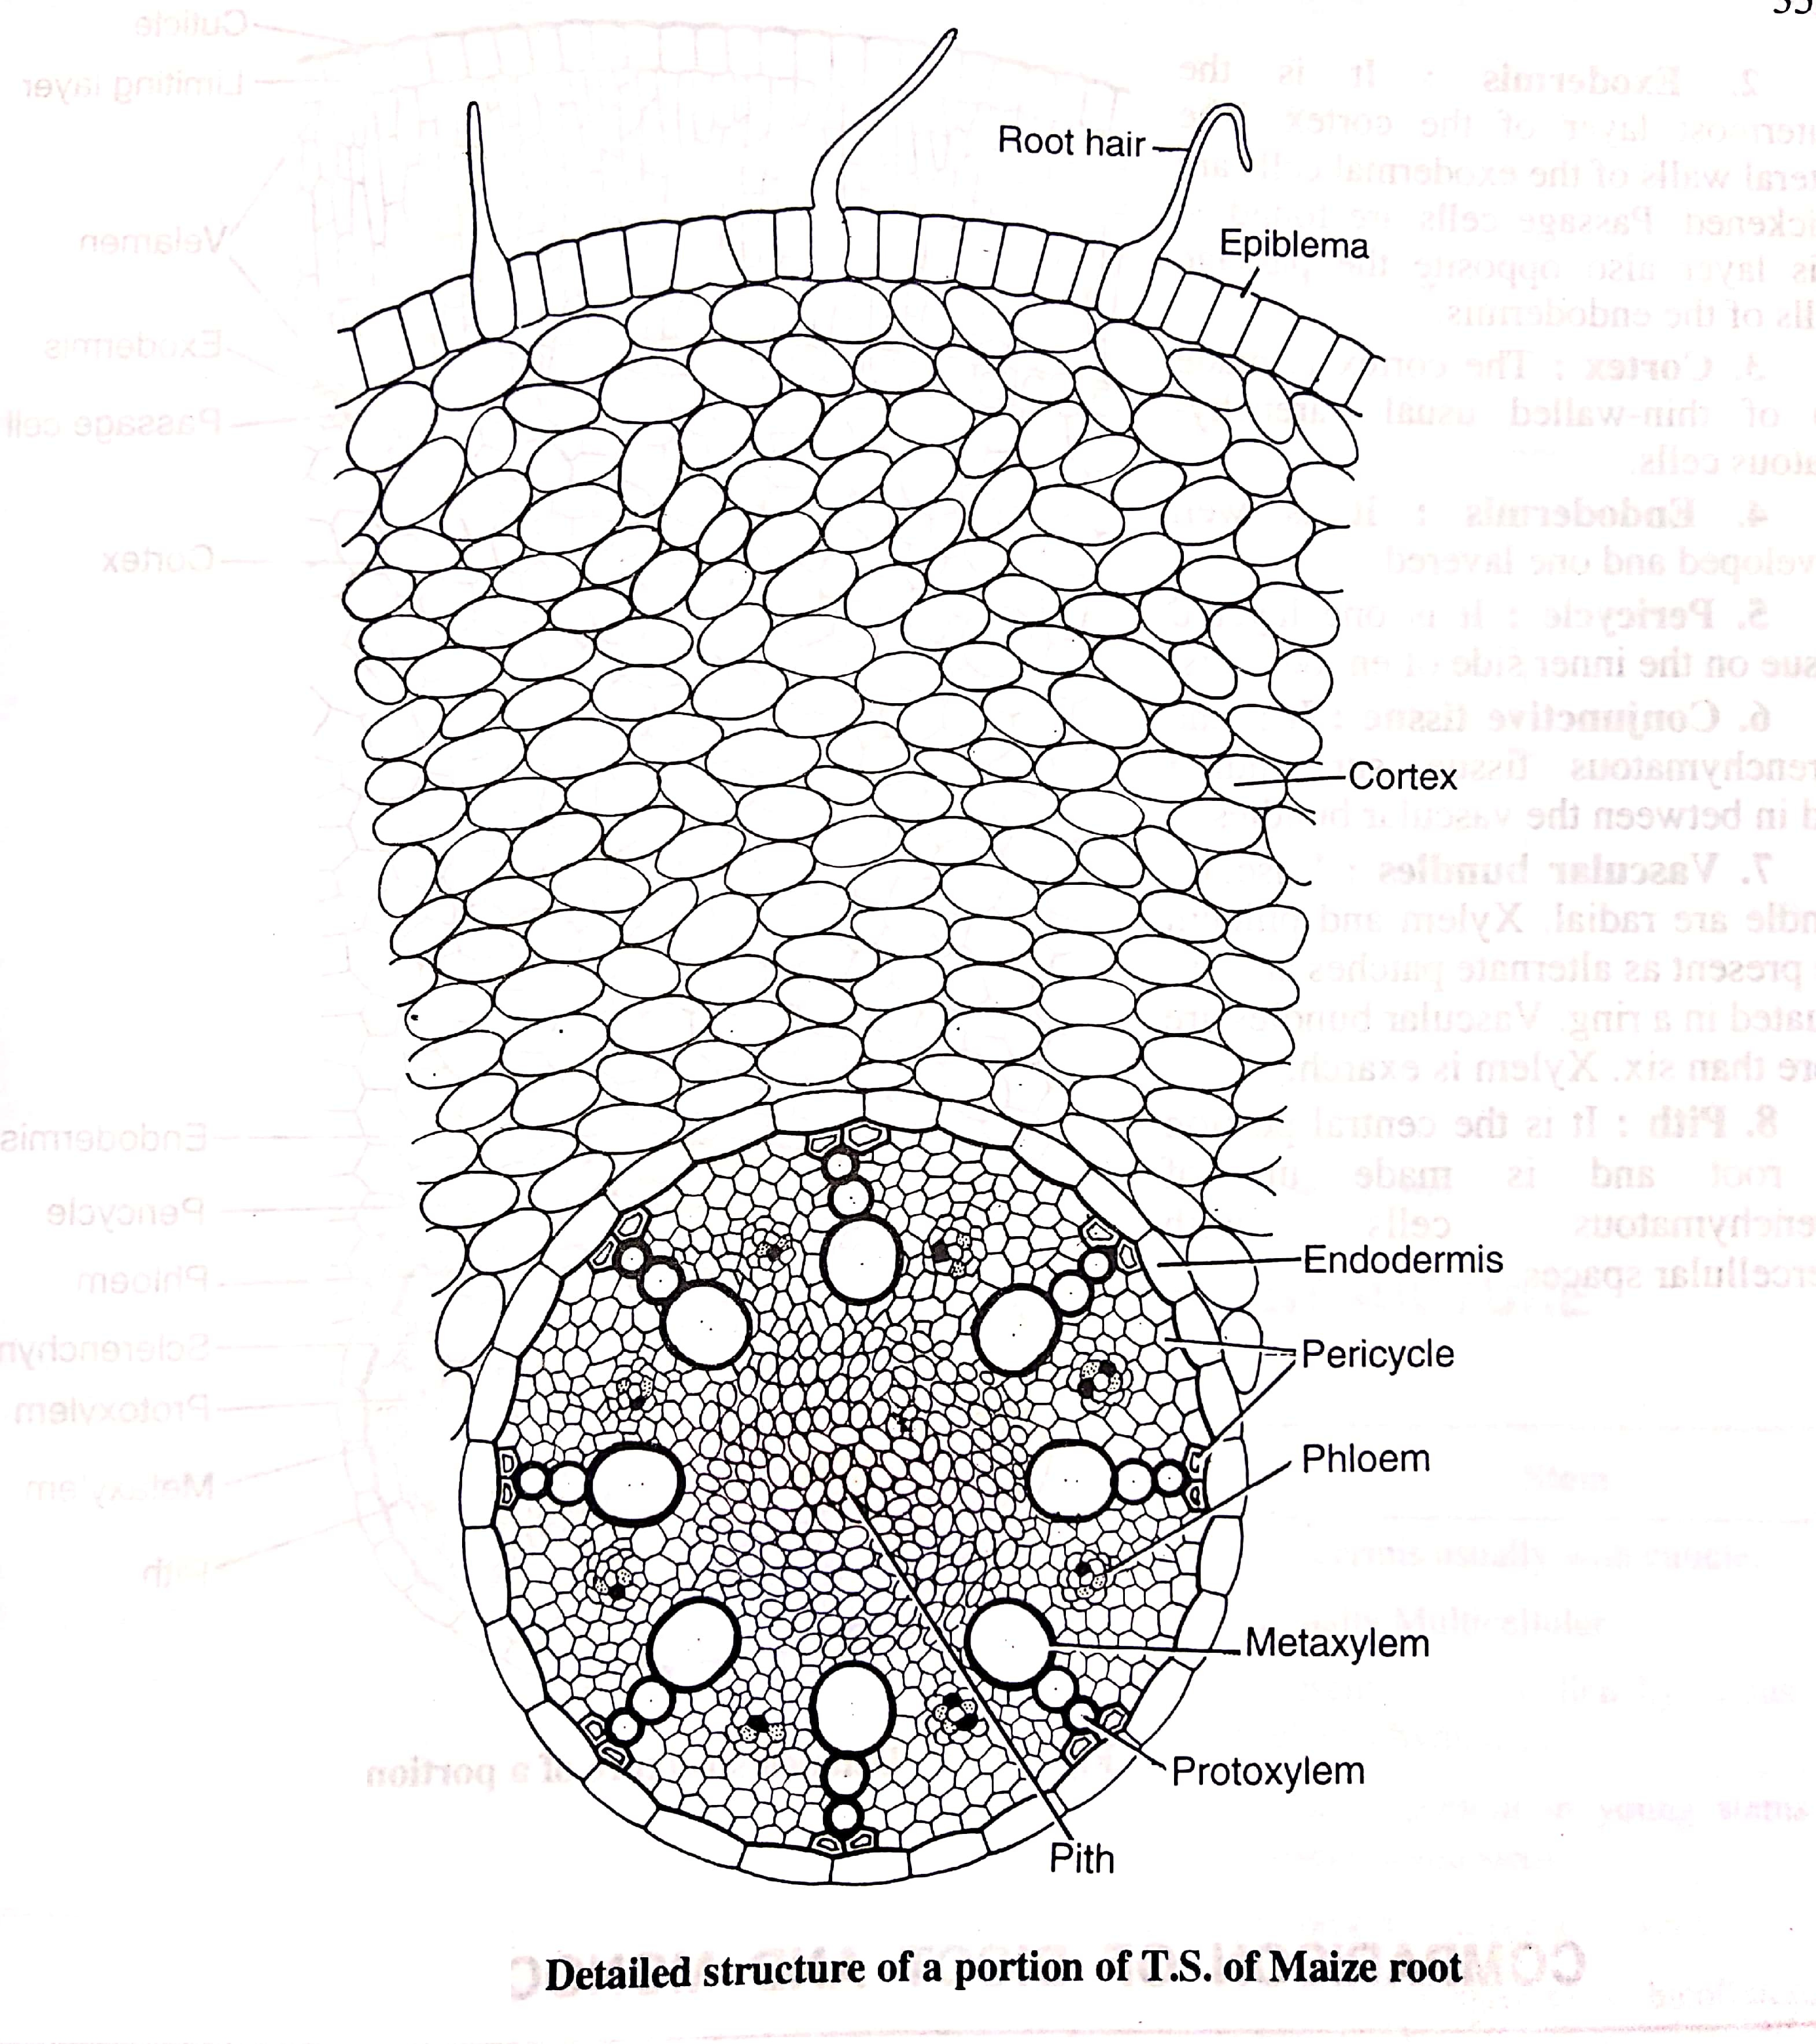

**COMPARISON OF DICOT AND MONOCOT ROOT**

|  |  |  |
| --- | --- | --- |
| **Characteristics** | **Dicot root** | **Monocot root** |
| 1. Pericycle | Gives rise to secondary roots and cork cambium | Gives rise to lateral roots only. |
| 1. Vascular bundles | Diarch to hexarch, i.e., vascular bundles are 2 to 6 | Polyarch condition, i.e., more than 6 vascular bundles. |
| 1. Cambium | Develops at the time of secondary growth | Absent |
| 1. Pith | Small and after secondary growth obliterate completely | Well developed |

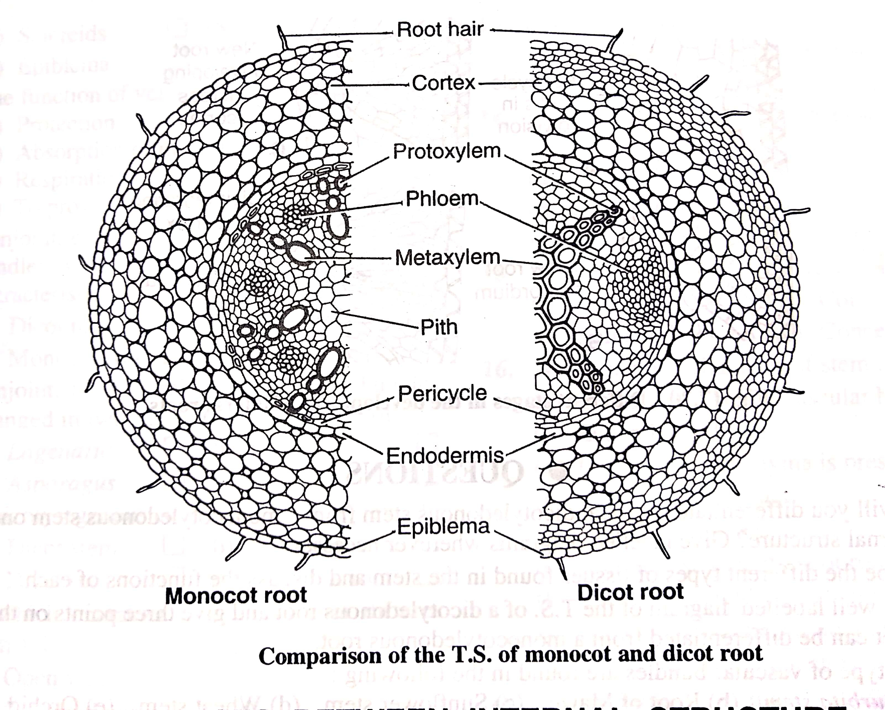

# **DIFFERENCES BETWEEN INTERNAL STRUCTURE OF ROOT AND STEM**

|  |  |  |
| --- | --- | --- |
| Characteristics | Root | Stem |
| 1. Epidermis or Epiblema | Epiblema or piliferous layer without cuticle | Epidermis usually with cuticle |
| 1. Epidermal Hairs | Unicellular | Usually Multicellular |
| 1. Hypodermis | Absent | Present collenchymatous or sclerenchymatous. |
| 1. Chlorenchyma in cortex | Absent | Usually present in young stems but absent in old stem. |
| 1. Endodermis | Distinct | Poorly developed or absent. |
| 1. Vascular bundle | Radial | Conjoint collateral or bicollateral or concentric. |
| 1. Xylem | Exarch | Endarch |

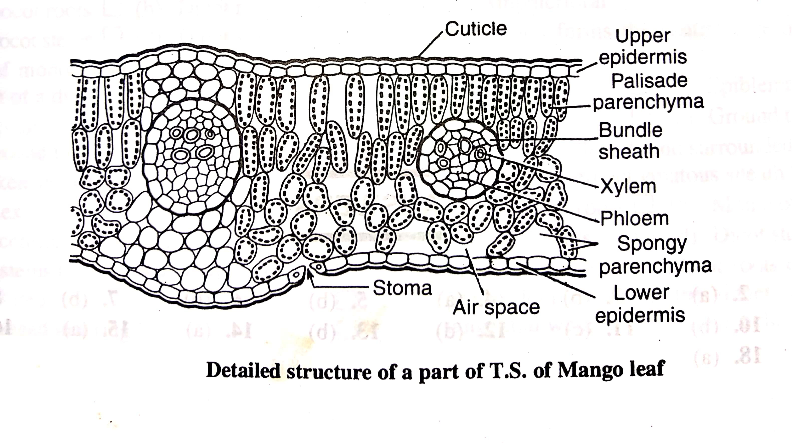

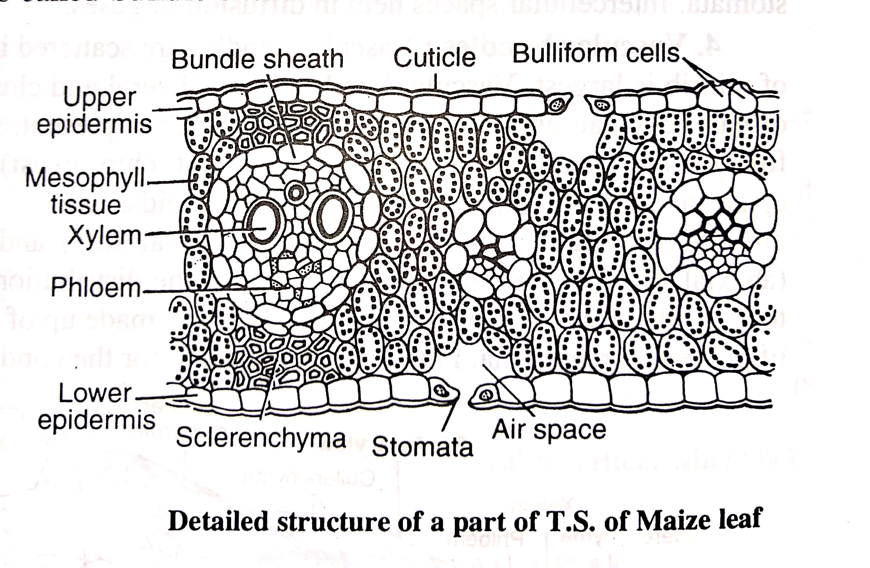

**DIFFERENCE IN THE ANATOMY OF DICOT AND MONOCOT LEAVES**

|  |  |  |
| --- | --- | --- |
| **Character** | **Dicot leaf** | **Monocot leaf** |
| Type of leaf | Dorsiventral. | Isobilateral |
| Stomata | Usually more on lower epidermis. | Equal on lower and upper epidermis |
| Mesophyll | Made up of two types of tissues :  (a) Palisade parenchyma  (b) Spongy parenchyma with large intercellular spaces | Only spongy parenchyma is present which has very small intercellular spaces. |
| Bundle sheath | Made up of parenchyma. Just above and below the vascular bundle some parenchymatous cells or collenchymatous cells are present up to epidermis. | Made of parenchyma but just above and below the vascular bundles are found sclerenchymatous cells (up to epidermis) |
| Bulliform cells | Absent. | Present, particularly in grasses |

